Accessibility

Accessible design lets people of all abilities interact with, understand, and navigate our products.

Products and web properties need to be accessible to everyone, including those with vision, hearing, cognitive, or motor impairments.

Accessible design is everyone's responsibility, from information and user experience design, through to development, and on into help and support. It is about understanding the users' journeys and proactively anticipating their needs.

To make sure products are accessible to everyone, follow the [four principles of the Web Content Accessibility Guidelines](https://www.w3.org/TR/UNDERSTANDING-WCAG20/intro.html#introduction-fourprincs-head):

1. **Perceivable:** It can be perceived by at least one of a person's senses.
2. **Operable:** All interactions are operable through a variation of input methods.
3. **Understandable:** Information and operation of the interface must be understandable.
4. **Robust:** Content can be interpreted by a variety of assistive technologies and withstand changes in these technologies.

Structure and hierarchy

Consistent, clear hierarchy helps people who navigate the page using links or headers. Use headings and titles to outline the page so people can see the structure and how sections relate to each other.

Be predictable with structure and use patterns and layouts familiar to people.

Content should be visible, so avoid putting important information inside accordions.

List by level of importance

Place items on the page in order of their level of importance so people don't have to search for them.

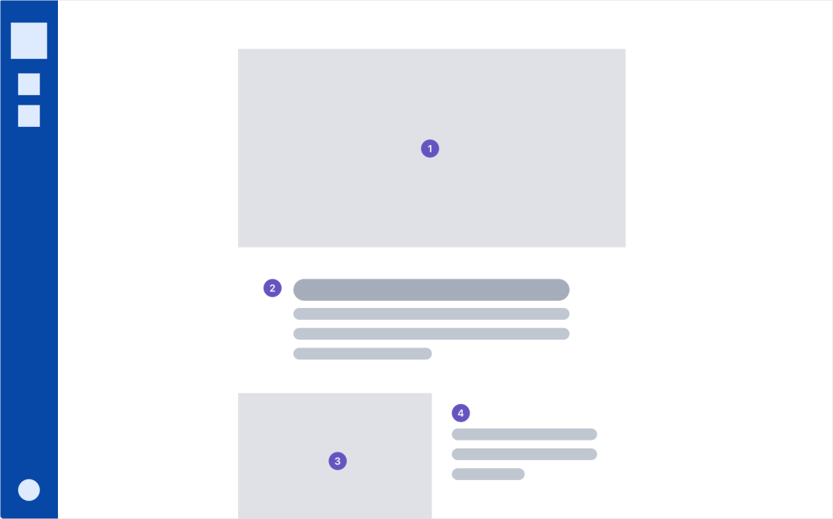

Have a consistent hierarchy

Create and maintain a consistent hierarchy so that people can use alternative input methods to move through the page. Headings are in order without skipping levels.

DO

Use a consistent heading hierarchy: H1, H2, H3, H4

DON'T

Use headings out of order: H2, H1, H3, H3

Text scaling

Test the UI with color correction, magnification, and other accessibility settings to ensure the layout works with assistive settings.

Group similar items

Group items under titles or headings that clearly communicate the content of the group.

DO

Clear title with related items: Fruit - wildberry, strawberry, blueberries.

DON'T

Vague category with unrelated items: Things - rocket, fuel, bring home milk.

Keyboard navigation

Some people can't use a mouse and navigate through applications using tools such as a keyboard, mouth wand, or eye tracking system. People should be able to navigate and use the product with a keyboard or screen reader. Make sure anything that can be seen by hovering with a mouse is also accessible to keyboard focus and screen readers.

When creating an application, check if a keyboard can be used to:

* navigate
* perform the same tasks as people who use a mouse
* locate where you are on the page
* tell where the keyboard focus is

Manage focus

Keyboard focus follows the page as the eye would scan it. Focus travels top to bottom, left to right, moving from most to least important item. People can navigate applications using alternative input methods (D-pads, trackballs, keyboards, and navigation gestures), and the focus flows in a logical order.

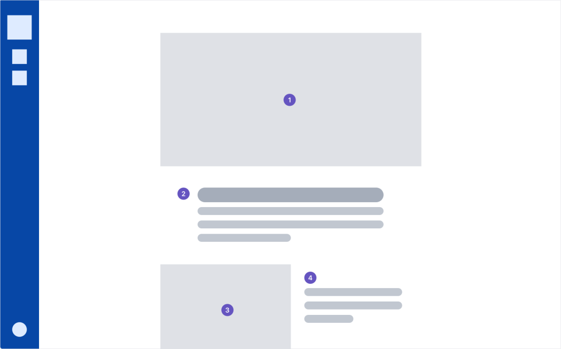

When assessing keyboard focus:

* Be conscious of the order of elements on the page. Do they make sense from the user's perspective?
* Indicate where focus is.
* Avoid using input focus to select, trigger events, or display messages. People may need to navigate through all controls before making changes.
* Keep in mind where the focus moves when the element in focus disappears. People should return to wherever they were before they focused on the element.

Use tooltips

Tooltips can be activated by keyboard. When an element gets keyboard focus, a tooltip displays. When that element loses focus, the tooltip disappears.

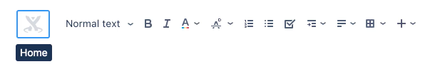

Validate forms inline

Validate forms inline so keyboard users don't have to navigate far to get feedback.

Ideally, design interactions to prevent errors happening in the first place and help people fix problems as they occur.

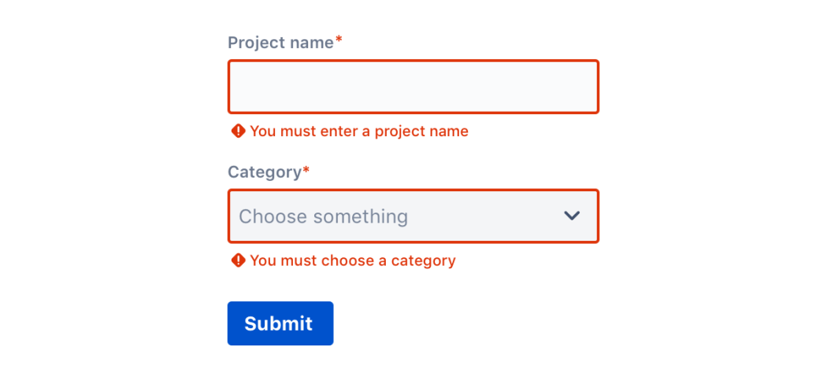

Meaningful text

Consistent and helpful text makes the user interface accessible to people who use a screen reader. Screen readers help people with visual impairments by reading both visible and non-visible alternative text aloud.

All text should support accessibility, whether it's visible (UI labels, headings, buttons, forms, hyperlinks, and help text) or non-visible (alternative text for images and buttons).

Be concise and use plain English

Keep content and accessibility text concise. People using screen readers hear every UI element read aloud, so the shorter the text, the faster they can navigate the content.

Screen readers can skim more easily and skip irrelevant paragraphs if you keep sentences short and frontload paragraphs with important information.

Plain English helps people skim and digest information faster. It also makes content more accessible to those who speak English as a second, third, or fourth language.

Avoid idioms and always expand acronyms when using them for the first time.

Use consistent labels

Consistently label elements and components that have the same functionality. When people encounter these elements in different contexts, they should be able to recognize and understand the function or actions of an element. For instance, a menu item that is labeled *All sprints* should open a page that is titled *All sprints*. A dialogue with the title *Copy page* has a button labeled *Copy*.

DO

Copy a ticket, copy a page

DON'T

Clone a ticket, copy a page

Describe what an element does

Label elements with action verbs that indicate what happens when the element is selected.

DO

Edit preferences - When read aloud, the text indicates the action.

DON'T

Preferences - Just labeling the element doesn't make it clear what will happen when it is selected.

Buttons

In buttons, describe what the action does and, if you can, reveal what will happen.

DO

Add room

DON'T

Go for it!

Hyperlinks and skip links

Link text should indicate where the link navigates to.

Add skip links or anchors to help people navigate around content pages.

DO

Learn more about Jira permissions

DON'T

Read more

Images and video

For important information, use text rather than images. Only use images that usefully add to the text.

Describe non-text elements in the UI or with alternative text so screen readers can succinctly describe images and media.

Avoid moving or flashing images if possible.

Images that contain information

If an image contains information that can only be understood by seeing the image, then you need to explain the content of the image using alternative text. Follow these guidelines when you write alt text:

* The text should be an adequate replacement for both the content and the function of the image.
* Determine the correct content and then deliver that message as succinctly as possible. Aim for no more than a few words, though sometimes a short sentence or two may be necessary.
* Don't repeat information that is contained in the text found on the page around the image.
* Don't use phrases like "image of ..." or "a photo of ..." to describe the image. This is apparent when using screen readers and the description itself should be enough to replace the meaning of the image.
* If the meaning and content of an image is conveyed by surrounding text, header, or captions, then you might not need as much alternative text.

Decorative images

If the image is used strictly to make the page pleasant to the eye, doesn't contain a link, and isn't used to deliver information, then include the alt attribute, but leave it empty. For example, *alt=""*

Complex images

A complex image could be a diagram, table or chart. Depending on the level of complexity, the image may need text near it explaining the contents, short alt text that complements this and possibly a link to a page with a long text description.

Videos

Provide transcripts and in-sync captioning. Make sure users can control when the video or gif starts and stops.

Provide audio description for any text displayed in a video.

Colors

We comply with [AA standard contrast ratios](http://www.w3.org/TR/WCAG/). To do this, we choose primary, secondary and extended colors that support usability. This ensures sufficient color contrast between elements so that people with low vision can see and use our products.

Include visual cues

Don't convey information using color alone. Use multiple visual cues, such as stroke weight, patterns, shape, text, or illustrations to ensure that everyone receives the same information. This helps people who are unable to, or have difficulty with, distinguishing one color from another. This includes people who are color blind, have low vision, or are blind.

For example, these inline validation messages use both color and icons to distinguish severity:

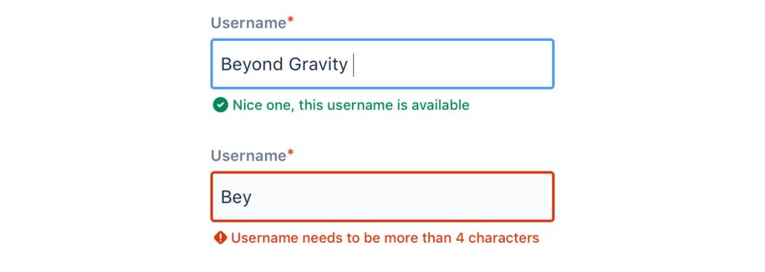

Use high contrast

High color contrast helps people who are partially or completely color blind see differences between certain colors. It creates a strong visual hierarchy and improves usability for everyone. Make sure that the combination of text and background color do not fall below the [WCAG recommended threshold](https://www.w3.org/TR/UNDERSTANDING-WCAG20/visual-audio-contrast-contrast.html) ratio of 4.5:1 for standard text and 3:1 for larger text.

Decorative images and disabled states don't have contrast requirements.

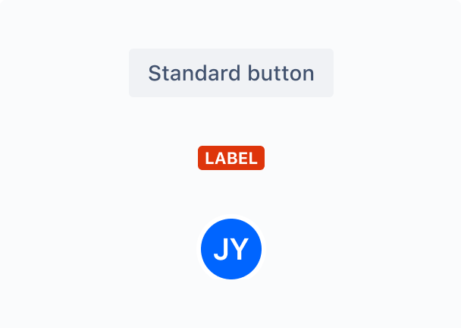

DO

Use high contrast color combinations that pass AA compliance.

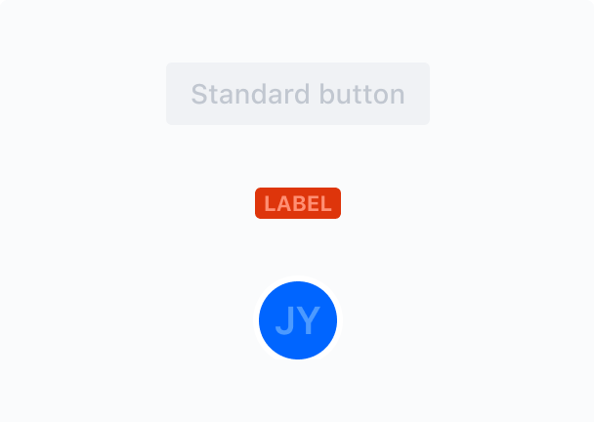

DON'T

Don't use low contrast color combinations that fail AA compliance.

Testing and research

These guidelines will help improve accessibility in your applications, but they don't guarantee a fully accessible experience. We also recommend you:

* test the entire application and journeys using various assistive technologies and text scaling
* include people with impairments when testing
* ensure the tasks in your applications can be accomplished by anyone, regardless of ability

When in doubt, refer to the [Web Content Accessibility Guidelines 2.1](https://www.w3.org/TR/WCAG21/).

# Color

Color distinguishes our brand and helps us create consistent experiences across products.

Use focused, meaningful color to pinpoint exactly what people need to see. We are committed to complying with the [Web Content Accessibility Guidelines AA standard contrast ratios](http://www.w3.org/TR/WCAG/). To do this, choose primary, secondary, and extended colors that support usability by ensuring sufficient color contrast between elements so that people with low vision can see and use our products.

Where appropriate, we enable people to introduce their own [color palettes](https://atlassian.design/foundations/color-palette). Our products adapt intelligently and flexibly to cater to different needs and preferences.

## Primary palette

Our primary palette is comprised of neutrals, white, and blue to bring boldness to our brand and is used in logical ways throughout product and marketing to guide the eye and highlight the important bits. We pepper warmer, secondary palette colors throughout to soften the experience and to impart confidence and optimism.

We use blue (B400) for primary actions, buttons, text links, for indicating progress and representing authentication. Neutral (N800) is used primarily for body text and headings, and white (N0) is used for page backgrounds.

Download our [color palettes](https://atlassian.design/resources/color-palette-resources).

A

FAIL

A

FAIL

A

PASS

A

PASS

#### NAME

B400 - Pacific bridge

#### HEX

#0052CC

#### RGB

0, 82, 204

A

FAIL

A

FAIL

A

PASS

A

PASS

#### NAME

N800 - Squid ink

#### HEX

#172B4D

#### RGB

23, 43, 77

A

PASS

A

PASS

A

FAIL

A

FAIL

#### NAME

N0 - Doctor

#### HEX

#FFFFFF

#### RGB

255, 255, 255

## Secondary palette

Our secondary palette contains a variety of colors to keep things fresh and interesting. We lean on these colors more frequently when brand awareness is high, or on our own properties where we control the surrounding environment. When used in conjunction with our primary palette, these colors make every moment feel on-brand and every interaction informative.

Our secondary palette is made up of red (R300), yellow (Y300), green (G300), teal (T300), and purple (P300). Each color is selected intentionally to provide meaningful feedback within our products. See the semantic color guidelines below for more information.

A

PASS

A

FAIL

A

PASS

A

FAIL

#### NAME

R300 - Poppy surprise

#### HEX

#FF5630

#### RGB

255, 86, 48

A

PASS

A

PASS

A

FAIL

A

FAIL

#### NAME

Y300 - Golden state

#### HEX

#FFAB00

#### RGB

255, 171, 0

A

PASS

A

PASS

A

FAIL

A

FAIL

#### NAME

G300 - Fine pine

#### HEX

#36B37E

#### RGB

54, 179, 126

A

PASS

A

PASS

A

FAIL

A

FAIL

#### NAME

T300 - Tamarama

#### HEX

#00B8D9

#### RGB

0, 184, 217

A

FAIL

A

FAIL

A

PASS

A

PASS

#### NAME

P300 - Da' juice

#### HEX

#6554C0

#### RGB

101, 84, 192

## Extended palette

The extended palette consists of all the useable tints and shades of each color in the palette. They are all numbered for easy reference. Usage of these colors varies depending on the touch point, but they come in handy for illustrations and components in product.

### Neutrals

Neutrals have varying degrees of saturation that allow for the appropriate level of warmth across marketing and product. Typically they are used for text and subtle backgrounds when we don't want to draw too much attention to a particular touchpoint or convey information such as "to do" or "disabled".

#### Dark neutrals

Dark neutrals are very effective for creating contrast and are therefore the primary color used for typography. Occasionally the dark neutrals are found in illustration but they rarely dominate the palette. Some exceptions are dark mode UI elements and illustrations.

A

FAIL

A

FAIL

A

PASS

A

PASS

#### NAME

N900 - Slate

#### HEX

#091E42

#### RGB

9, 30, 66

A

FAIL

A

FAIL

A

PASS

A

PASS

#### NAME

N800 - Squid ink

#### HEX

#172B4D

#### RGB

23, 43, 77

A

FAIL

A

FAIL

A

PASS

A

PASS

#### NAME

N700 - Snorlax

#### HEX

#253858

#### RGB

37, 56, 88

A

FAIL

A

FAIL

A

PASS

A

PASS

#### NAME

N600 - Pet rock

#### HEX

#344563

#### RGB

52, 69, 99

A

FAIL

A

FAIL

A

PASS

A

PASS

#### NAME

N500 - McFanning

#### HEX

#42526E

#### RGB

66, 82, 110

#### Mid-neutrals

Use mid-neutrals to create depth in components such as modal dialog blankets and cards. Avoid mid-neutrals as background colors because there is usually not enough contrast to remain AA compliant. The mid-neutrals N400 to N200 can be used for subtle text and icons on light-neutral backgrounds. You can find text style using these colors in [Typography](https://atlassian.design/foundations/typography).

A

FAIL

A

FAIL

A

PASS

A

PASS

#### NAME

N400 - Concrete jungle

#### HEX

#505F79

#### RGB

80, 95, 121

A

FAIL

A

FAIL

A

PASS

A

PASS

#### NAME

N300 - Clooney

#### HEX

#5E6C84

#### RGB

94, 108, 132

A

PASS

A

FAIL

A

PASS

A

PASS

#### NAME

N200 - Bling bling

#### HEX

#6B778C

#### RGB

107, 119, 140

A

PASS

A

FAIL

A

PASS

A

FAIL

#### NAME

N100 - Humboldt fog

#### HEX

#7A869A

#### RGB

122, 134, 154

A

PASS

A

PASS

A

PASS

A

FAIL

#### NAME

N90 - Meredith

#### HEX

#8993A4

#### RGB

137, 147, 164

A

PASS

A

PASS

A

FAIL

A

FAIL

#### NAME

N80 - Spooky ghost

#### HEX

#97A0AF

#### RGB

151, 160, 175

A

PASS

A

PASS

A

FAIL

A

FAIL

#### NAME

N70 - Blanche

#### HEX

#A5ADBA

#### RGB

165, 173, 186

A

PASS

A

PASS

A

FAIL

A

FAIL

#### NAME

N60 - Sentinel

#### HEX

#B3BAC5

#### RGB

179, 186, 197

#### Light neutrals

We use light neutrals as subtle backgrounds to indicate various interactive states such as hover and disabled, or simply to create secondary attention towards a component. You'll find light neutrals in buttons, text fields, tags, and illustrations.

Light neutrals are helpful for offsetting content in a primarily white layout without losing warmth and cleanliness and are therefore often used as a background color. Their subtlety allows for them to be helpful in creating subtle shadows or depth in illustration, and they can also be helpful in depicting illustrative objects that are typically made of metallic materials like hardware, or atmospheric elements in illustrations, like clouds.

A

PASS

A

PASS

A

FAIL

A

FAIL

#### NAME

N50 - Karl

#### HEX

#C1C7D0

#### RGB

193, 199, 208

A

PASS

A

PASS

A

FAIL

A

FAIL

#### NAME

N40 - Jolly fun time

#### HEX

#DFE1E6

#### RGB

223, 225, 230

A

PASS

A

PASS

A

FAIL

A

FAIL

#### NAME

N30 - Northeast snow

#### HEX

#EBECF0

#### RGB

235, 236, 240

A

PASS

A

PASS

A

FAIL

A

FAIL

#### NAME

N20 - Gram's hair

#### HEX

#F4F5F7

#### RGB

244, 245, 247

A

PASS

A

PASS

A

FAIL

A

FAIL

#### NAME

N10 - Wash me

#### HEX

#FAFBFC

#### RGB

250, 251, 252

A

PASS

A

PASS

A

FAIL

A

FAIL

#### NAME

N0 - Doctor

#### HEX

#FFFFFF

#### RGB

255, 255, 255

### Red

Red is mainly used for backgrounds in messages and in error states to draw attention to important information or actions that are destructive or block workflow. You'll find red used in components such as lozenges, banner, flag messages, buttons, illustrations, and typography.

A

FAIL

A

FAIL

A

PASS

A

PASS

#### NAME

R500 - Dragon's blood

#### HEX

#BF2600

#### RGB

191, 38, 0

A

PASS

A

FAIL

A

PASS

A

PASS

#### NAME

R400 - Red dirt

#### HEX

#DE350B

#### RGB

222, 53, 11

A

PASS

A

FAIL

A

PASS

A

FAIL

#### NAME

R300 - Poppy surprise

#### HEX

#FF5630

#### RGB

255, 86, 48

A

PASS

A

PASS

A

FAIL

A

FAIL

#### NAME

R200 - Salmon sashimi

#### HEX

#FF7452

#### RGB

255, 116, 82

A

PASS

A

PASS

A

FAIL

A

FAIL

#### NAME

R100 - Alexandria

#### HEX

#FF8F73

#### RGB

255, 143, 115

A

PASS

A

PASS

A

FAIL

A

FAIL

#### NAME

R75 - Bondi sunburn

#### HEX

#FFBDAD

#### RGB

255, 189, 173

A

PASS

A

PASS

A

FAIL

A

FAIL

#### NAME

R50 - Rosie

#### HEX

#FFEBE6

#### RGB

255, 235, 230

### Yellow

Yellow indicates a warning or that progress is impeded. Yellow feels right at home in components like lozenges, banners, flag messages, and buttons.

A

PASS

A

PASS

A

FAIL

A

FAIL

#### NAME

Y500 - Debrito

#### HEX

#FF8B00

#### RGB

255, 139, 0

A

PASS

A

PASS

A

FAIL

A

FAIL

#### NAME

Y400 - Cheezy blasters

#### HEX

#FF991F

#### RGB

255, 153, 31

A

PASS

A

PASS

A

FAIL

A

FAIL

#### NAME

Y300 - Golden state

#### HEX

#FFAB00

#### RGB

255, 171, 0

A

PASS

A

PASS

A

FAIL

A

FAIL

#### NAME

Y200 - Pub mix

#### HEX

#FFC400

#### RGB

255, 196, 0

A

PASS

A

PASS

A

FAIL

A

FAIL

#### NAME

Y100 - Cowbell

#### HEX

#FFE380

#### RGB

255, 227, 128

A

PASS

A

PASS

A

FAIL

A

FAIL

#### NAME

Y75 - Dandelion whisper

#### HEX

#FFF0B3

#### RGB

255, 240, 179

A

PASS

A

PASS

A

FAIL

A

FAIL

#### NAME

Y50 - James blonde

#### HEX

#FFFAE6

#### RGB

255, 250, 230

### Green

We use green to indicate success or to celebrate a win. Green goes well with lozenges, badges, toggles, messages, and illustrations. Keep in mind that our green is very vibrant, which can cause eye strain in large doses. However, because of this vibrancy, it can also stand out well among many other elements on a page, which is why it is a good choice for calls-to-action and buttons in marketing.

A

FAIL

A

FAIL

A

PASS

A

PASS

#### NAME

G500 - Keen green

#### HEX

#006644

#### RGB

0, 102, 68

A

PASS

A

FAIL

A

PASS

A

PASS

#### NAME

G400 - Slime

#### HEX

#00875A

#### RGB

0, 135, 90

A

PASS

A

PASS

A

FAIL

A

FAIL

#### NAME

G300 - Fine pine

#### HEX

#36B37E

#### RGB

54, 179, 126

A

PASS

A

PASS

A

FAIL

A

FAIL

#### NAME

G200 - Green tea

#### HEX

#57D9A3

#### RGB

87, 217, 163

A

PASS

A

PASS

A

FAIL

A

FAIL

#### NAME

G100 - Cloverleaf

#### HEX

#79F2C0

#### RGB

121, 242, 192

A

PASS

A

PASS

A

FAIL

A

FAIL

#### NAME

G75 - Mintie

#### HEX

#ABF5D1

#### RGB

171, 245, 209

A

PASS

A

PASS

A

FAIL

A

FAIL

#### NAME

G50 - The smell

#### HEX

#E3FCEF

#### RGB

227, 252, 239

### Blue

Blue is used to help us reinforce our presence and unify our touchpoints from marketing to product. It's sharp and clear, making it bold and optimistic, while at the same time it's soft and inviting, paying homage to the practical, human origins of Atlassian. It is at the heart of every communication and should be used intentionally but sparingly. As with all colors in the palette, you should be mindful of the color values provided in these guidelines. When used appropriately and accurately, the colors have an incredible impact.

Blue is used to indicate authentication, connectivity, or progress. You'll find blue in messages, buttons, navigation, lozenges, badges, tabs, and the progress tracker.

A

FAIL

A

FAIL

A

PASS

A

PASS

#### NAME

B500 - Chore coat

#### HEX

#0747A6

#### RGB

7, 71, 166

A

FAIL

A

FAIL

A

PASS

A

PASS

#### NAME

B400 - Pacific bridge

#### HEX

#0052CC

#### RGB

0, 82, 204

A

FAIL

A

FAIL

A

PASS

A

PASS

#### NAME

B300 - Sodium explosion

#### HEX

#0065FF

#### RGB

0, 101, 255

A

PASS

A

FAIL

A

PASS

A

FAIL

#### NAME

B200 - Coogee

#### HEX

#2684FF

#### RGB

38, 132, 255

A

PASS

A

PASS

A

FAIL

A

FAIL

#### NAME

B100 - Arvo breeze

#### HEX

#4C9AFF

#### RGB

76, 154, 255

A

PASS

A

PASS

A

FAIL

A

FAIL

#### NAME

B75 - Schwag

#### HEX

#B3D4FF

#### RGB

179, 212, 255

A

PASS

A

PASS

A

FAIL

A

FAIL

#### NAME

B50 - Pixie dust

#### HEX

#DEEBFF

#### RGB

222, 235, 255

### Teal

Teal can typically be found in illustrations or as an accent color for components such a tags.

A

PASS

A

FAIL

A

PASS

A

FAIL

#### NAME

T500 - Shabby chic

#### HEX

#008DA6

#### RGB

0, 141, 166

A

PASS

A

PASS

A

PASS

A

FAIL

#### NAME

T400 - Prom dress

#### HEX

#00A3BF

#### RGB

0, 163, 191

A

PASS

A

PASS

A

FAIL

A

FAIL

#### NAME

T300 - Tamarama

#### HEX

#00B8D9

#### RGB

0, 184, 217

A

PASS

A

PASS

A

FAIL

A

FAIL

#### NAME

T200 - Mermaid net

#### HEX

#00C7E6

#### RGB

0, 199, 230

A

PASS

A

PASS

A

FAIL

A

FAIL

#### NAME

T100 - Hairy fairy

#### HEX

#79E2F2

#### RGB

121, 226, 242

A

PASS

A

PASS

A

FAIL

A

FAIL

#### NAME

T75 - Arctic chill

#### HEX

#B3F5FF

#### RGB

179, 245, 255

A

PASS

A

PASS

A

FAIL

A

FAIL

#### NAME

T50 - Gram's sofa

#### HEX

#E6FCFF

#### RGB

230, 252, 255

### Purple

Purple indicates help and support and is used in spotlight, buttons, messages, lozenges, and image callouts. It is also used to display visited links in web typography and as an accent color in illustration. However, it is best used in small doses in illustration as it can sometimes clash with blue.

A

FAIL

A

FAIL

A

PASS

A

PASS

#### NAME

P500 - Prince

#### HEX

#403294

#### RGB

64, 50, 148

A

FAIL

A

FAIL

A

PASS

A

PASS

#### NAME

P400 - Snozzberry

#### HEX

#5243AA

#### RGB

82, 67, 170

A

FAIL

A

FAIL

A

PASS

A

PASS

#### NAME

P300 - Da' juice

#### HEX

#6554C0

#### RGB

101, 84, 192

A

PASS

A

FAIL

A

PASS

A

FAIL

#### NAME

P200 - Pastelli

#### HEX

#8777D9

#### RGB

135, 119, 217

A

PASS

A

PASS

A

FAIL

A

FAIL

#### NAME

P100 - Herky jerky

#### HEX

#998DD9

#### RGB

153, 141, 217

A

PASS

A

PASS

A

FAIL

A

FAIL

#### NAME

P75 - Phantom mist

#### HEX

#C0B6F2

#### RGB

192, 182, 242

A

PASS

A

PASS

A

FAIL

A

FAIL

#### NAME

P50 - Lavender secret

#### HEX

#EAE6FF

#### RGB

234, 230, 255

## Semantic color

The following guidelines outline when to use colors in product. Semantic color helps users find people, identify status, see actions, locate help, and understand next steps. The consistent use of color keeps cognitive load low and makes for a unified and engaging user experience. In addition to the color usage guidelines for web, there are also iOS and Android application color guidelines that augment the color guidelines for those platforms.

